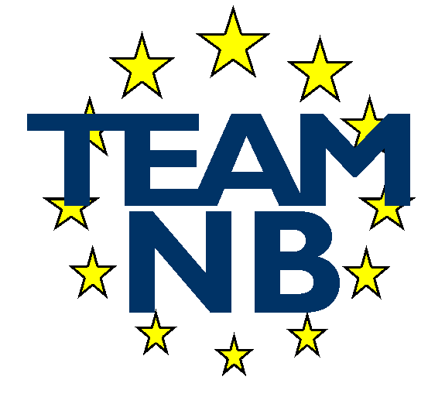  The European Association of Medical devices Notified Bodies | TEAM-NB A.I.S.B.L. Rue Bawepuce 20 B – 4140 Sprimont - BELGIUM Phone: +32 475 85 40 45 E-mail: assistant@team-nb.org Web: http://www.team-nb.org IBAN BE09 3401 5174 8757 VAT BE 0864 640 677

Editor : | Francoise SCHLEMMER |  | Date : | November 23rd, 2023
PRESS RELEASE
MDR Technical Documentation Training for Manufacturers

Team-NB is developing and delivering several training courses for manufacturers in response to some of the actions associated with Notified Bodies from MDCG 2022-14 and to specifically support Small and Medium Enterprises (SMEs) by enhancing their understanding of the legislative requirements. Team-NB intends to further strengthen its communications with manufacturers via other means such as publication of best practice guides, webinars, workshops, targeted feedback and informative sessions in the future.

As a part of the above initiative, Team-NB recently delivered its first training course for medical devices manufacturers on the subject of MDR technical documentation.

The MDR Technical Documentation course and its content were developed by medical devices experts from 9 notified bodies, namely BSI, CeCertiso, Dekra B.V., DNV, ECM, GMED, SGS, TÜV Rheinland and TÜV SÜD with the main aim of helping manufacturers to better understand the requirements and prepare/establish technical documentation that is compliant to the requirements of MDR. The course was also delivered by notified body experts.

The objectives of the training course were to:
- Explain the technical documentation related requirements from MDR;
- Cover aspects of the recently updated Team-NB Best Practice Guide on MDR Technical Documentation towards guidance on preparing technical documentation submissions;
- Share notified body interpretations, insights and first-hand experiences from technical documentation assessment
The course also included an interactive “Questions and answers” session to provide more practical guidance on topics of interest from the attendees.

The course took place on November 7th and was fully booked with 79 attendees from 50 different organisations with nearly ¾ being SMEs who also benefited from reduced pricing for the course.

Feedback was requested from the participants via a questionnaire to evaluate the outcomes of the course and also to understand the progress of the manufacturers towards their transition to MDR.

Key highlights from the feedback provided are shared below

Our 1st question was intended to have a better view on the distribution of the course participants and the question was: “what type of MDD manufacturer / others are you?”

The responses (N=70) showed that most of the participants were manufacturers and more specifically SMEs, fulfilling one of the aims of this Team-NB initiative to support SMEs.

Responses received to the question (posed to manufacturers only; N=62) “Have you already submitted your MDR Technical Documentation to a Notified Body?” indicate that all large manufacturers have submitted at least one technical file/documentation to their Notified Body while slightly greater than half of SMEs had submitted at least one.
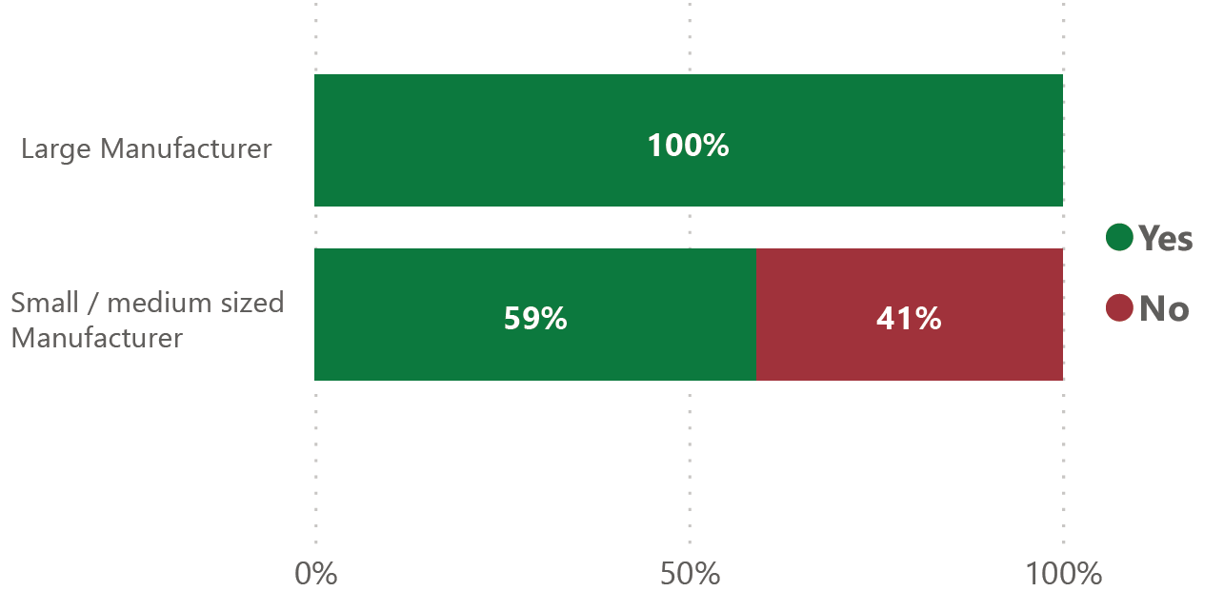

A follow-up question “What percentage of your technical documentation files have you updated for MDR?” was posed to manufacturers only to understand the progress of manufacturers in updating their technical documentation towards MDR compliance.

The responses (N= 61) generally indicate that large manufacturers have made more progress on updating their technical documentation compared to SMEs. However, this should be considered as an indication only as the sample size is too small to draw firm conclusions.

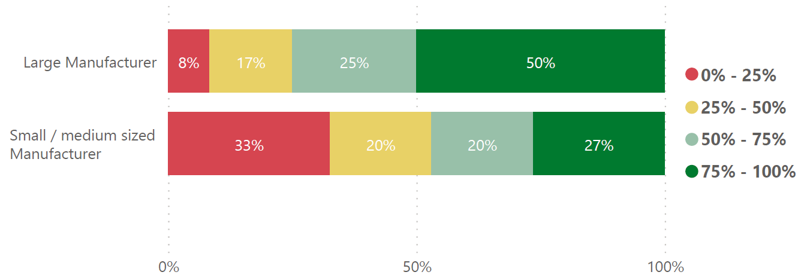

The training course was considered a success with >90% of the attendees indicating that their expectations were met and that majority of the attendees would recommend the training to others.

Based on the success of the first course and continued interest, a 2nd session is planned to take place in December 2023 and a 3rd session in February 2024. Team-NB’s goal is to continue our efforts to help manufacturers to meet the requirements of the MDR and IVDR.

- About Team-NB

Team-NB is the European Association for Medical Devices of Notified Bodies, Team-NB is dedicated to ensure a high level of patients’ safety and confidence.

Our three main areas of focus, have been and will remain:
- The promotion of innovation, but innovation that is backed by solid safety and effectiveness data. The certification of manufacturers’ products is essential to continue the confidence in Medical Devices and In-Vitro Diagnostic products.
- Our support to notified bodies, through our detailed and state of the art guidance documents, ensures a consistent standard is achieved by our members throughout Europe.
- Ultimately, Team-NB works to ensure continuous improvement of products, leading to increased patient access to safe innovative products.

Our main objectives, have been and will remain:
- To improve communications with the EC Commission, Industry, Competent Authorities and User Groups by acting as a focal point and the single voice of Notified Bodies
- To promote high technical and ethical standards in the functioning of Notified Bodies
- To increase competences in decision making processes
- To make available to the sector a competent work forces as quickly as possible
- To protect the legal and commercial interests of Notified Bodies in their vital role in the functioning of the three medical device directives.

Team-NB set up Mirror MDCG-working groups to allow the members the opportunity to support development of European guidance and enable comments on draft documents in order to coordinate and consolidate input.

Team-NB also set up task forces to address specific items in order to harmonise views and come with best practice guides. Today there are 25 tasks forces working on topics such as article 117, classification interpretation, cybersecurity, Lifetime,…

Moreover, the Team-NB academy organised several trainings related to the new MDR/IVDR with the aim to help notified bodies deal with new requirements in their assessments. Another purpose is to achieve a better harmonisation among notified bodies thanks to the exchanges that will be favoured during the presentations and the cases studies sessions.
Moreover, Experts session for harmonisation has been set up at the senior experts’ level to share their experience on burning evaluation topics. The objective is that attendees cascade the info into their organisation to reach all reviewers.

In case of any further clarification needed, please contact schlemmer@team-nb.org

