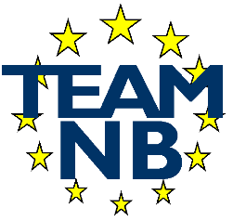 | The European Association Medical devices - Notified Bodies  MEMBER APPLICATION

I confirm we wish to be a member of the association TEAM-NB (European Association of Notified Bodies for Medical Devices).
I send as part of my candidature the signed latest version of the Code of Conduct and I agree to be invoiced the yearly fees.
I will then be allowed to access the private part of the site and considered a member awaiting confirmation. The validation of my status within Team-NB will be carried out by a vote of the members at the next general meeting.

Name of Notified Body
Notified Body Number
Address
Post Code
Locality
Country
Phone | …… - …… - ……………………..  Country Code – Area Code - Phone number
Fax | …… - …… - ……………………..
Web site
VAT Number
Notified for Directives  (tick where appropriate) | 90/385/EEC Directive  93/42/EEC Directive  98/79/EC Directive  Regulation (EU) 2017/745  Regulation (EU) 2017/746
Name of contact
Title of Contact
E-mail of Contact
Direct Phone | …… - …… - ……………………..  Country Code – Area Code - Phone number

Signature :
Name of signatory : | ……………………………………………
Date : | ……………………………………………

Please could you complete this form and send it back to the email address to the attention of Françoise SCHLEMMER (schlemmer@team-nb.org).

