|  |  |  |  |
| --- | --- | --- | --- |
| R-Logo-Team-NB-2-0  **T**he **E**uropean **A**ssociation of **M**edical devices **N**otified **B**odies | |  |  | | --- | --- | | TEAM-NB A.I.S.B.L.  Rue Bawepuce 20  B – 4140 Sprimont - BELGIUM  Phone: +32 475 85 40 45 | E-mail: assistant@team-nb.org  Web: <http://www.team-nb.org>  IBAN BE09 3401 5174 8757  VAT BE 0864 640 677 - RPM Liège | |

|  |  |  |  |  |
| --- | --- | --- | --- | --- |
| Editor : | Francoise SCHLEMMER |  | Date : | May 27th, 2025 |
| **PRESS RELEASE**  **MDR Clinical Training for Manufacturers** | | | | |

Team-NB is pleased to announce the results of participation in the first training session regarding the Clinical Evaluation Review of the Medical devices Regulation (EU) 2017/745.

This training for Manufacturers is intended for participants who are members of a manufacturer's clinical team and have experience in creating Clinical Evaluation Reports and/or are involved in CE submission.

Team-NB has developed and is delivering training courses for manufacturers in response to some of the actions associated with Notified Bodies from MDCG 2022-14 and to specifically support Small and Medium Enterprises (SMEs) by enhancing their understanding of the legislative requirements.

Team-NB has also supported this initiative in MDCG 2022-14 by making freely available to all manufacturers best practice guides for Technical Documentation.

Team-NB intends to further strengthen its communications and support of manufacturers via other means such as publication of other best practice guides, webinars, workshops, targeted feedback and informative sessions in the future.

The MDR Clinical course and its content were developed by medical devices experts from notified bodies members. with the main aim of helping manufacturers to better understand the requirements and prepare/establish technical documentation that is compliant to the requirements of MDR. The course was also delivered by notified body experts who have real world experience conducting conformity assessment.

The objectives of the training course were to:

* Focus of the clinical aspects with the aim to meet the technical documentation requirements from MDR;
* Cover aspects of the recently updated [Team-NB Best Practice Guide on MDR Technical Documentation](https://www.team-nb.org/wp-content/uploads/members/M2023/Team-NB-PositionPaper-BPG-TechnicalDocEU-MDR-2017-745-V2-20230419.pdf) towards guidance on preparing technical documentation submissions;
* Share notified body interpretations, insights and first-hand experiences from technical documentation assessment

The course also included an interactive “Questions and answers” session to provide more practical guidance on topics of interest from the attendees.

The course that took place on May 7th was the first training on this topic. There were 91 attendees from 53 different organisations with more than a half being SMEs who also benefited from reduced pricing for the course.

Feedback was requested from the participants via a questionnaire to evaluate the outcomes of the course and also to understand the progress of the manufacturers towards their transition to MDR.

We also received the below feedback by e-mail from one of the participants :

*I would like to sincerely thank you for today’s training session.*

*It was very well-structured, informative, and extremely helpful for our work. The content was both relevant and clearly presented.*

*A special mention to the speakers — they were clear, engaging, and maintained an excellent flow throughout the presentation, which made the session even more effective and pleasant to follow.*

*Looking forward to future sessions!*

Key highlights from the feedback provided are shared below:

Our 1st question was intended to have a better view on the distribution of the course participants and the question was: “what type of MDD manufacturer / others are you?”

The responses (N=69) showed that most of the participants were manufacturers and more specifically SMEs, fulfilling one of the aims of this Team-NB initiative to support SMEs.

Responses received to the question (posed to manufacturers only; N=68) “Have you already submitted your MDR Technical Documentation to a Notified Body?” indicate that 95% of large manufacturers and 75% of SMEs have submitted at least one technical file/documentation to their Notified Body.

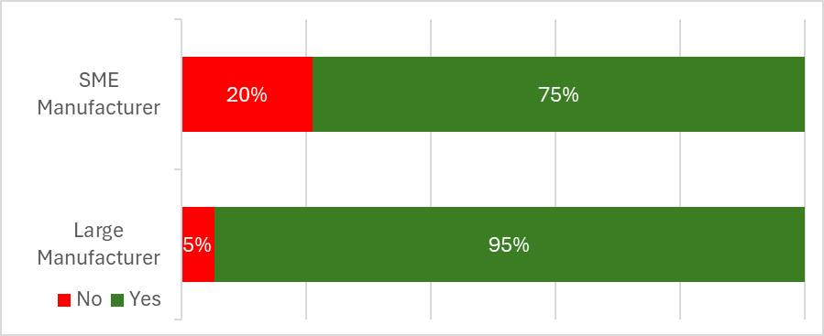

A follow-up question “What percentage of your technical documentation files have you updated for MDR?” was posed to manufacturers only to understand the progress of manufacturers in updating their technical documentation towards MDR compliance.

The responses (N=62) generally indicate that 70% of large manufacturers have updated half of their technical documentation which is comparable with the 66% updated by SMEs. However, this should be considered as an indication only as the sample size is too small to draw firm conclusions.

That said, these results demonstrate that there is still a significant effort to be made so that the technical files can be submitted to the notified bodies for certification. It should be remembered that the certification process according to the MDR is longer than before. These figures and the postponement of submissions identified by the notified bodies make us fear that regulation EU 2023/67 will simply have postponed the problem and that we will be faced with a new bottleneck in 2 years.

Furthermore, we thought it would be interesting to have answers to the question: What percentage of the medical device portfolio does your company intend to certify in accordance with the new MDR regulations and thus continue to market?

When you consider only manufacturers responses, you get the above results based on manufacturer size.

It is interesting to note that comparable results with part their product portfolio that will be continued to market. 88% of large manufacturers will continue to market more than 50% of their products and that 87% of the SMEs as well.

The training course was considered a success with 100% of the attendees indicating that their expectations were at least partially met and that majority of the attendees would recommend the training to others.

Based on the success, Team-NB’s goal is to continue our efforts to help manufacturers to meet the requirements of the MDR and IVDR with both training on technical documentation and the on focus on clinical aspects.

The next meeting regarding clinical aspects is scheduled for August 27th.

* **About Team-NB**

Team-NB is the European Association for Medical Devices of Notified Bodies, Team-NB is dedicated to ensure a high level of patients’ safety and confidence.

Our three main areas of focus, have been and will remain:

* The promotion of innovation, but innovation that is backed by solid safety and effectiveness data. The certification of manufacturers’ products is essential to continue the confidence in Medical Devices and In-Vitro Diagnostic products.
* Our support to notified bodies, through our detailed and state of the art guidance documents, ensures a consistent standard is achieved by our members throughout Europe.
* Ultimately, Team-NB works to ensure continuous improvement of products, leading to increased patient access to safe innovative products.

Our main objectives, have been and will remain:

* To improve communications with the EC Commission, Industry, Competent Authorities and User Groups by acting as a focal point and the single voice of Notified Bodies
* To promote high technical and ethical standards in the functioning of Notified Bodies
* To increase competences in decision making processes
* To make available to the sector a competent work forces as quickly as possible
* To protect the legal and commercial interests of Notified Bodies in their vital role in the functioning of the three medical device directives.

Team-NB set up **Mirror MDCG-working groups** to allow the members the opportunity to support development of European guidance and enable comments on draft documents in order to coordinate and consolidate input.

Team-NB also set up **task forces** to address specific items in order to harmonise views and come with best practice guides. Today there are 25 tasks forces working on topics such as article 117, classification interpretation, cybersecurity, Lifetime,…

Moreover, the **Team-NB** **academy** organised several trainings related to the new MDR/IVDR with the aim to help notified bodies deal with new requirements in their assessments. Another purpose is to achieve a better harmonisation among notified bodies thanks to the exchanges that will be favoured during the presentations and the cases studies sessions.

Moreover, **Experts** **session for harmonisation** has been set up at the senior experts’ level to share their experience on burning evaluation topics. The objective is that attendees cascade the info into their organisation to reach all reviewers.

In case of any further clarification needed, please contact [schlemmer@team-nb.org](mailto:schlemmer@team-nb.org)