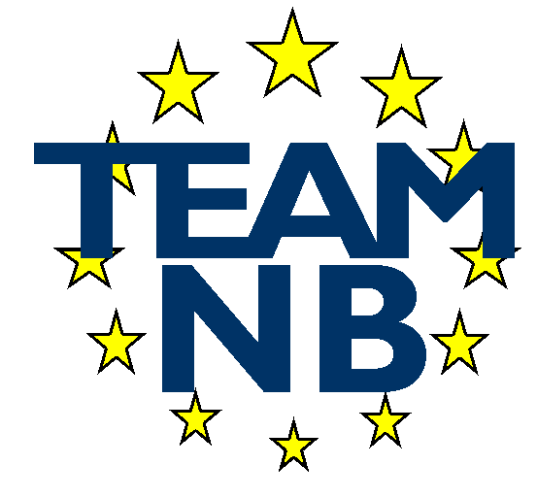  The European Association of Medical devices Notified Bodies
  TEAM-NB A.I.S.B.L.  Rue Bawepuce 20  B – 4140 Sprimont - BELGIUM  Phone: +32 475 85 40 45 | E-mail: assistant@team-nb.org  Web: http://www.team-nb.org  IBAN BE09 3401 5174 8757  VAT BE 0864 640 677 - RPM Liège

Editor |  |  | Date: | 08/04/2026
Have your say - Public Consultations and Feedback
Published initiatives
Medical devices and in vitro diagnostics – targeted revision of EU rules
Feedback (4000 characters max)

Team NB, the European Association of Medical Devices Notified Bodies, welcomes the opportunity to provide comments on the draft medical Devices and in vitro diagnostics – targeted revision of EU rules.

We support the Regulation's objective of ensuring that only safe and effective devices are placed on the EU market, thereby safeguarding safety and public health while fostering innovation.

That being said, Team-NB believes that the draft introduces a cumulative and systematic reduction of preventive regulatory safeguards, which increases risks to patient safety and public health. The proposed measures jointly reduce notified body involvement across certification and surveillance activities, including sampling, unannounced audits, surveillance audits, SS(C)Ps and PSURs, removal of recertification and expiry dates, and reduced transparency obligations. Viewed cumulatively, these changes would lower regulatory oversight to a level below that applied under the Directives (AIMDD/MDD/IVDD), shifting the EU system from a preventive to a predominantly reactive model.

Today, the control system represents 0.28% of the medical device sector in Europe. Significantly reducing such controls would be unlikely to generate substantial cost savings while posing significant risk to our public health system.

Notified bodies also consider that "for cause" interventions will, on the one hand, open the door to endless discussions and, on the other hand, represent a negative approach. Rather than reducing regulatory scrutiny across the board, Team-NB proposes a performance-based oversight model that rewards sustained regulatory compliance and high-quality manufacturer performance. Reduced surveillance intensity should be earned, time-limited, justified, and reversible, and should only be considered after successful completion of multiple compliant review cycles, without major non-conformities or unresolved safety issues.

Removing recertification could only be considered acceptable if it is replaced by a robust, performance-based periodic review framework that compensates for any reduction in systematic notified body oversight. Periodic review must remain preventive in nature and explicitly differentiate between early-lifecycle, stable-lifecycle, and late-lifecycle risks, with regulatory intensity adjusted based on demonstrated compliance performance and emerging safety signals.

Team-NB raises serious concerns regarding the proposed amendments to Article 10. Articles 10(9)(f)–(g) reintroduce OEM manufacturing arrangements that separate regulatory liability from effective control over design and technical documentation. Under the proposed structure, manufacturers would retain full legal responsibility for compliance while potentially lacking access to, or authority over, critical design evidence, creating unacceptable regulatory and liability risks.
We also object to the proposed removal of Article 10(16). This provision is a cornerstone of the MDR liability framework, as it explicitly establishes the manufacturer’s primary responsibility for device compliance and the obligation to hold adequate insurance coverage. Its deletion would remove a critical anchor of legal certainty for patients, authorities, and the regulatory system as a whole.

We also have a general request for clear definitions and removal of ambiguities. We see recurring issues throughout MDR/IVDR implementation, where unclear legal wording affects consistency and operational clarity. This includes, in particular, clarification of clinical data sources, constraints on the use of non-clinical data routes, a clear and restrictive framework for well-established technologies. Further clarification is required to enable IVD-specific controls, particularly for evaluating the performance of device types for which computer modeling and silico testing are appropriate for generating performance data. In addition, a definition of equivalence is required for IVDs.

A recently updated list of “Well Established Technologies” devices has been published by the Commission. Team-NB supports the use of a binding list of well-established technology devices, accompanied by a clearly constrained legal definition. Such lists should be maintained through implementing acts, transparently indicate accepted and rejected device types, and must not be used to justify reduced oversight for higher-risk devices.

We support the need for careful attention to costs and administrative burdens, particularly for SMEs, in implementing the legislation. However, we note that many notified bodies are SMEs and that the proposed system introduces additional administrative burden and reduces flexibility. Furthermore, the proposal appears to prioritize cost savings without adequately considering the potential impact on patient safety and the risk of reduced regulatory coverage. State backed innovation and enterprise development agencies across Member States could provide support mechanisms for SMEs.

As far as administrative burden is concerned, notified bodies consider that increasing the frequency of Joint Assessments to every two years constitutes an unnecessary addition particularly in light of increasing transparency in notified body activities. This scrutiny would exceed that applied to manufacturers under the proposal and should therefore not be introduced. The current JAT timescales should be maintained.

Team-NB welcomes the European database, EUDAMED which is expected to become a valuable tool. It is crucial that notified bodies designated under MDR and IVDR are granted direct and comprehensive access to EUDAMED modules, commensurate with their legal responsibilities under Articles 83–86 and Annexes III and IX. Without such access, notified bodies cannot effectively perform surveillance, periodic review, or benefit-risk assessment, undermining the preventive intent of the Regulations.”

Notified Bodies are supportive of their involvement in expert panels. Indeed, Notified Bodies hold a wealth of expertise that could be utilised for expert panels. We encourage the Commission and EMA to include Notified Body experts in these panels going forward.

Team-NB remains committed to supporting improvements in the regulatory framework. It will continue to promote high standards and work towards harmonizing practices among notified bodies in Europe. These bodies are committed to encouraging the continuous improvement and development of products, thereby enabling patients to have timely access to safe and innovative devices, supported by robust safety and efficacy data.

