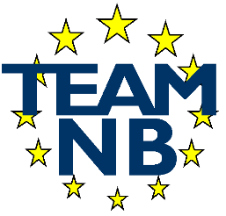  The European Association Medical Devices - Notified Bodies
  TEAM-NB A.I.S.B.L.  Boulevrd Frère Orban 35A  B – 4000 Liège BELGIUM  Tel.: + 32 (0)4 254 55 88 | E-mail: secretary@team-nb.org  Web: http://www.team-nb.org  VAT BE0864.640.677  IBAN BE09 3401 5174 8757

Editor : | Francoise SCHLEMMER |  | Date : | May 18th, 2026.
PRESS RELEASE
Team-NB sector survey 2025

Since 2010, all Team-NB members contribute to the annual Team-NB survey. This allows Team-NB to provide data on the sector over the past year and to identify trends by comparison with data from previous years.

As last year, the questionnaire maintained the questions aimed to shed light on specific transitions for certain articles (16, 17, 22), for artificial intelligence aspects or for Annex XVI of Regulations 2017/745 and 2017/746, where applicable. In addition, the question focused on certificates issued under MDSAP was also maintained.

By the end of 2025, the number of notified bodies that were members of the association reached 44. It should be noticed that the total number of Team-NB members includes "candidate members" which are still in the designation process. The 2025 survey compiled data from 41 Notified Bodies. These members are designated under two regulations or three directives.

Below some explanatory graphs of our 2025 members survey.

- Breakdown of the notified bodies size

Team-NB applies a breakdown of the notified bodies size defined by the number of certificates issued against Regulations only as follow:
“big” | “medium” | “small”
above 1000 certificates | between 300 and 1000 certificates | less than 300 certificates

The 2025 distribution is
“big” | “medium” | “small”
5 % | 15% | 80%

It is worth noting a significant change in the distribution of notified bodies based on the number of certificates issued compared to the previous year. However, in 2024, the certificates issued also included those issued in accordance with Directives and application acknowledgments letters.
  - 17 % organisations issuing more than 1000 certificates
  - 32% organisations issuing between 300 and 1000 certificates and
  - 51% organisations issuing less than 300 certificates.

- Evolution of the number of Regulations certificates

MDR applications and certificates (QMS + Product)
The growth is presented below for MDR with information to be considered on the
number of designated members of Team-NB compared to the total number of designated notified bodies:

In 2025, we see a slowdown in growth both in the issuance of certificates and in applications received.

Legend: 2020: 16 members / 18 designated NBs
2021: 21 members / 25 designated NBs
2022: 25 members / 36 designated NBs
2023: 32 members / 42 designated NBs
2024: 39 members / 50 designated NBs
2025: 41 members / 52 designated NBs

In comparison with the results of the “Study supporting the monitoring of availability of medical devices on the EU market” presented to December 2025, Team-NB certificates represent 81% of the total issued and the applications received are representing 84%.
That being said, with data from 41 members out of a total of 52 designated notified bodies, Team-NB represents 79% of the market share.

IVDR applications and certificates
The growth is presented below for IVDR with information to be considered on the
number of designated members of Team-NB compared to the total number of designated notified bodies:

In 2025, we also see a slowdown in growth both in the issuance of certificates and in applications received for the IVD sector.

Legend: 2020: 4 members / 4 designated NBs
2021: 6 members / 6 designated NBs
2022: 6 members / 7 designated NBs
2023: 10 members / 12 designated NBs
2024: 10 members / 12 designated NBs
2025: 13 members / 19 designated NBs

In comparison with the results of the “Study supporting the monitoring of availability of medical devices on the EU market” presented to December 2025, Team-NB certificates represent 95% of the total issued and the applications received are representing 86%.
That being said, with data from 16 members out of a total of 19 designated notified bodies, Team-NB represents 84% of the market share.

- Certificates split among the 2 regulations annexes:

The 2 below graphs shows the distribution of certificates between different conformity assessment modules under MDR (left) and IVDR (right)

- Particular transitions to MDR and IVDR

For information, below are the responses to the request concerning particular transitions to both regulations in terms of issued certificates and received applications.

It should be noted that there has been a significant decrease in submissions under Annex XVI; by a half. Although the number of Annex XVI certificates issued have increased in line with the last year increase of submissions.

Regarding AI/machine learning devices, the number of submissions has decreased significantly by a half and the number of certificates issued has increased by 40% in line with the last year increase of submissions.

It is worth noting a significant increase in Class D applications, with 30% to be compare with the last year growth of 70%. The number of Class D certificates issued has increased by 62% to be compare with 170% of last year.

- Others certifications

Beside the certifications against directives and/or regulations for medical devices, the notified bodies are also providing other certifications in the international frameworks to ensure recognition over the world.

Compared to 2024, in 2025 the number of certificates issued by members according to the ISO 13485 standard is increasing by 8%; on the other hand, there is a stagnation in the number of certificates according to the MDSAP format.

- Size of manufacturers
Data from Team NB members shows that a substantial proportion of MDR/IVDR certificates in 2025 were issued to manufacturers located outside the EU, and that half of the micro and small manufacturers placing devices on the EU market are non EU based.

Below are complete data on the sizes of manufacturers in EU and outside EU for both Regulations.
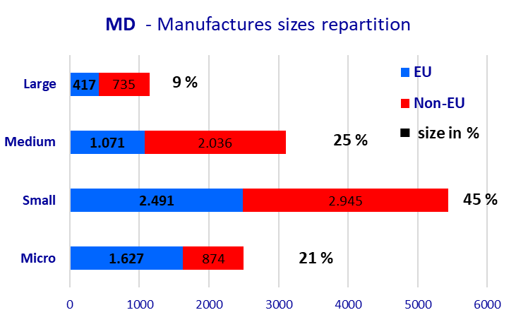 | 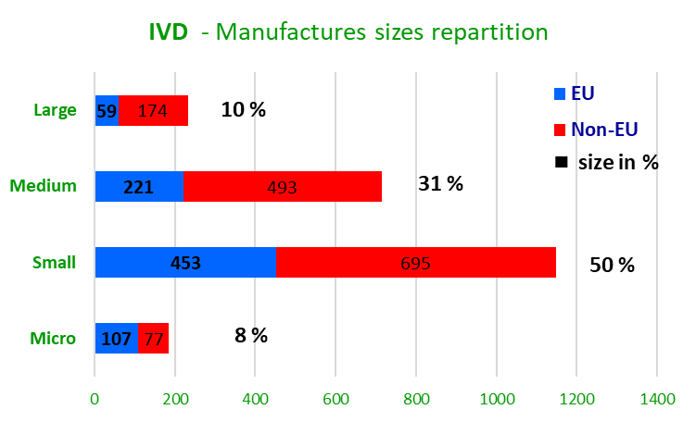

This information is provided following proposal to introduce obligatory and considerable discount on Notified Body fees for micro and small manufacturers, regardless of whether they are established inside or outside the EU. While the intention—to support smaller companies—is understandable, several unintended consequences should be considered.

- Full time employees

Until 2020, the data included all Notified Bodies employees for both doing conformity assessments and being administrative supports. From 2021, the focus was put on technical resources being entitled to do conformity assessments.

The data below shows that notified bodies were forced to lay off staff in 2025 in order to maintain operations. These decisions were difficult. Furthermore, given that training a staff member requires an investment of 12 to 18 months, the resumption of activities cannot be immediate. To date, we continue to observe a decrease in the number of submissions received and therefore in the workload. This trend is expected to continue until the vote on the regulatory revisions. In this context, some bodies may be forced to close down.

We note that for the first time in over 10 years the number of employees within the company is decreasing.
In particular,
- The number of internal employees for conformity assessment decreased by 8%.
- The number of subcontractors also decreased by 21%.

These figures confirm that notified bodies had more than enough resources to meet market needs.
Now they have too many resources. Technical resources are overstaffed due to the suspension of manufacturers' applications and the postponement of ongoing procedures.

- Completeness check

Under the regulations, Notified Bodies are required to ensure that the complete technical documentation has been received (sometimes referred to as a completeness check) before undertaking a review of its content.

We can see the evolution of the completeness of the received technical documentation is improving concerning the MDR regulation.

That said there are still 65% of submitted files that are missing half of the needed information and thus they request additional information to be able to start the assessment.

Unfortunately, the completeness of the received IVD technical documentation is still to be improved with 42% of submitted files that are missing three quarters of the needed information.

To help the Manufacturers to meet the regulations requirements and to improve the quality of applications, Team-NB published Technical Documentation Best Practice Guidance documents for both MDR and IVDR.
Team-NB is also going on with the organisation of trainings sessions for MD and IVD technical documentation since June 2023 with respectively:
  - 5 sessions for IVD with a total 331 participants from 181 organisations knowing that a 6th session is going to take place on July 2nd.
  - 10 sessions for MD with a total 788 participants from 444 organisations knowing that a 11th session is going to take place on April 29th.
Additionally, to meet participants' requests, Team-NB has developed a session focused on clinical aspects:
  - 4 sessions for MDR Clinical with a total of 341 participants from 193 organizations. Registrations exceeded the limit to allow for fruitful exchanges, and we have already planned a fifth session to take place on May 28th.

The full survey is available on our web site as a graphical presentation. http://www.team-nb.org/documents-2025/

- About Team-NB

Team-NB is the European Association for Medical Devices of Notified Bodies, Team-NB is dedicated to ensure a high level of patients’ safety, performance and confidence.

Our three main areas of focus, have been and will remain:
- The promotion of innovation, but innovation that is backed by solid safety and effectiveness data. The certification of manufacturers’ products is essential to continue the confidence in Medical Devices and In-Vitro Diagnostic products.
- Our support to notified bodies, through our detailed and state of the art guidance documents, ensures a consistent standard is achieved by our members throughout Europe.
- Ultimately, Team-NB works to ensure continuous improvement of products, leading to increased patient access to safe innovative products.

Our main objectives, have been and will remain:
- To improve communications with the European Commission, Industry, Competent Authorities and User Groups by acting as a focal point and the single voice of Notified Bodies
- To promote high technical and ethical standards in the functioning of Notified Bodies
- To increase competences in decision making processes
- To make available to the sector a competent work forces as quickly as possible
- To protect the legal and commercial interests of Notified Bodies in their vital role in the functioning of the three medical device directives.

Team-NB set up Mirror MDCG-working groups to allow the members the opportunity to support development of European guidance and enable comments on draft documents in order to coordinate and consolidate input.

Team-NB also set up task forces to address specific items in order to harmonise views and come with best practice guides. Today there are 31 tasks forces working on topics such as article 117, classification, cybersecurity,…

Furthermore, the Team-NB Academy organises training courses on 12 different topics related to the MDR and IVDR regulations to help notified bodies train their auditors on the requirements for assessments. Another objective is to promote greater harmonisation among notified bodies through the exchanges encouraged during presentations and case studies.
Moreover, harmonisation sessions on clinical aspects (MDR) and performance (IVDR) are held regularly to allow senior experts to share their experience on the most crucial assessment issues. The aim is for participants to disseminate this information within their organisations to further improve harmonisation among notified bodies.
Trainings for manufacturers are also offered on the topics of technical documentation for MDR, for IVDR, as well as clinical data.

In case of any further clarification needed, please contact : schlemmer(at)team-nb.org.

