Editor : | Team-NB | Adoption date | 28/01/2022 | Version 1.0
Team-NB Notified Bodies recommendations
on the handling of modifications to the device sampling plans

Following MDCG 2019-13 guidance issued in December 2019, this position paper further clarifies the management of modifications of a sampling plan due to the addition or removal of the devices certified.
This position paper gives scenarios for changes to the sampling plan both for initial certification and post-certification.
Scenarios during initial certification and during the certification cycle:
As per MDCG 2019-13 4.1.1. Sampling prior to issuing a QMS certificate, and 4.1.2 sampling during surveillance, Notified Bodies should sample:
- at least one device (i.e. one Basic UDI-DI) file per group for initial certification and at least an additional file in every group over the certificate cycle
- There will be at least one technical documentation assessment per year
- If the Technical Documentation files of all devices have been reviewed already, the TD assessment will focus on the Post-Market Surveillance (Annex III) and changes introduced since the last review
- Quantitative for surveillance – at least 5% or 15% of devices to be sampled of each group
Example 1:
The Manufacturer has two groups. Samples are taken for initial certification as per MDCG2019-13 4.1.1 as shown in the table below. These do not count towards the quantitative number required for surveillance.
More than one of the Class C group may be required to be sampled, if the group recommendation for the scope cannot be made based on one device e.g., if devices are clinically diverse within the same code/s; or if there are differences in technology within the same IVP code.
For surveillance, 1 device of the Class B group is required. It would be sensible to put this review towards the end of the certificate cycle, and prioritise the Class C surveillance.

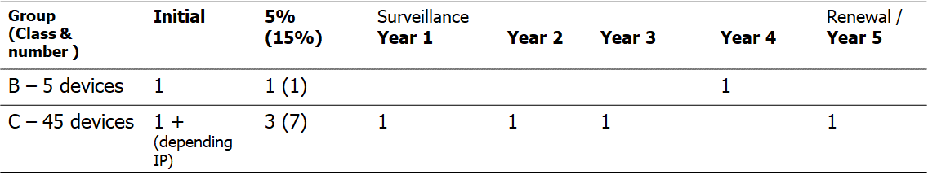

For the Class C group, 3 devices are required to be sampled (5%). This number would rise to 7 devices after the first certificate cycle.
The additional 4th device (year 5) is sampled to satisfy the basic requirement to sample at least 1 device per year as per section 4.1.2 of MDCG 2019-13. It is up to the discretion of the NB to decide from which group this additional device shall be sampled.

Example 2

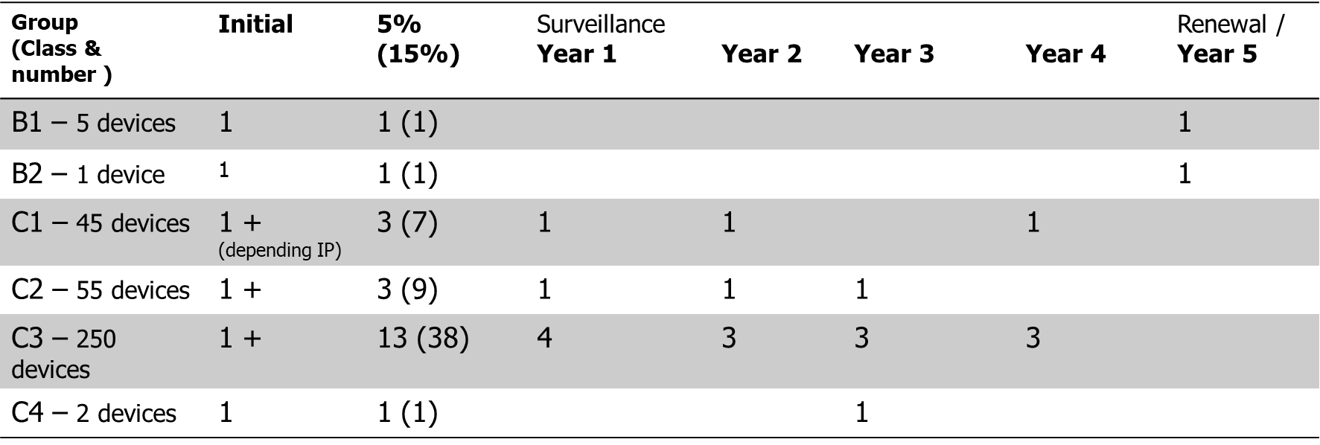

Manufacturer has six groups, of both Class B and Class C devices.
Initial samples are taken for initial certification. When there are a greater number of devices in groups, the surveillance percentage will increase significantly in the second certificate cycle.
As for example 1, for surveillance, the Class C devices should be prioritised.

For example, in year 1, the technical documentation for six devices will be reviewed; in year 2, the technical documentation for five sampled devices will be reviewed.

Scenarios post-certification :
- Addition to existing generic device groups / categories
The sampling plan will need to be adjusted to reflect the increased number of devices to ensure the 5% in the first certification cycle and the 15% of sampled devices in subsequent cycles is maintained.
Qualitative criteria such as novelty of the technology, intended purpose (e.g. target population) would need to be considered for sample selection as per section 4.2 of MDCG 2019-13.
The additional Technical Documentation to be reviewed can be added at any given year during the certification cycle as decided by the NB. The 5% rule should be applied to the entire number of devices covered and reduced correspondingly to the number of years left in the certification cycle i.e. if only 2 years are left, 2% of the total number of devices will need to be reviewed.
The number of TDs to be reviewed should be rounded up to the next whole number.
At certificate renewal, the 15% rule will apply also to the newly added device groups/categories.

Example 1a
The initial certification involved two groups, class B (5 devices) and class C (45 devices). Let’s assume the Manufacturer adds 5 class B devices in Year 2 post certification and 50 class C devices to the already certified groups. The total number of devices will now be 10 for class B and 95 for class C; the sampling plan will need to be reviewed to reflect the increased number of devices and taking into account the addition happened in Year 2.
The initial plan (Table 1) used for certification and year 1 surveillance, would need to be amended for example as follows:
Table 1a

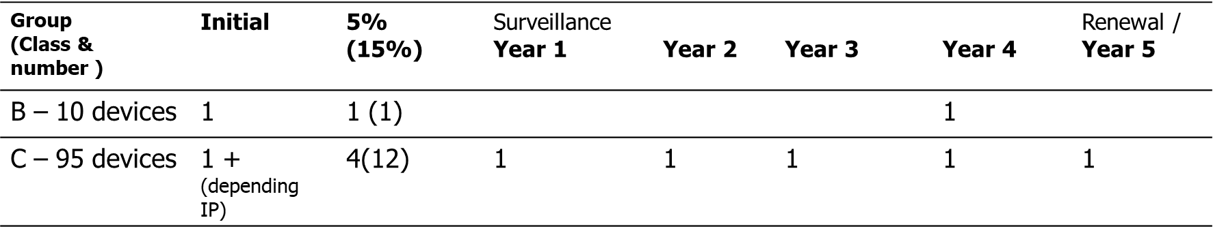

Example 2a

The initial certification involved Manufacturer has six groups, of both Class B and Class C devices.
Let’s assume the Manufacturer adds 60 devices to group B2 in Year 3 post certification and 85 devices to group C4. The total number of devices will now be 61 for group B2 and 87 for group C4; The initial sampling plan (Table 2) will need to be reviewed to reflect the increased number of devices and taking into account the addition happened in Year 3, for example as follows:

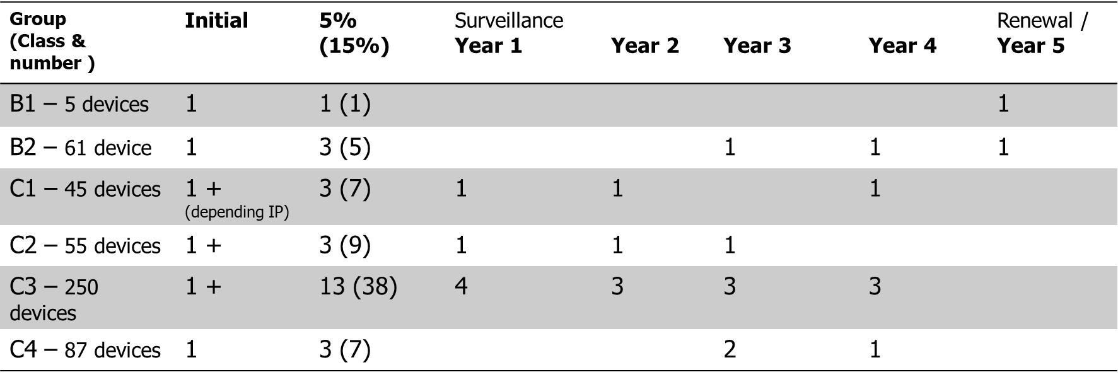

- Addition of new generic device groups / categories of devices
In this case, initial sampling criteria would need to be applied and a sampling plan based on the total number of devices added to the certificate should be developed.
As an example, if a manufacturer adds 1 class C generic device group and 1 class B device category, the revised sampling plan should include at least one device of the added generic device group and one of the added device category.
The 5% rule should be applied to each individual group/category of devices covered and reduced correspondingly to the number of years left in the certification cycle i.e., if only 2 years are left, 2% of the total number of devices will need to be reviewed.
The same principle applies if new device groups/categories are added in the second certification cycle but using the 15% rule.

- Addition of new devices to existing device groups/categories together with addition of new generic device groups/categories of devices
The same principles laid out in point 1 and 2 should be applied for each individual group/category contained in the amendment application.
- Removal of device groups/categories after the initial certification

In case of withdrawal/cancellation/ refusal the sampling plan is updated to remove the entire group/category and an assessment of the potential need for alternative devices to be sampled should be done.

- Removal of individual devices within a group/category after the initial certification
In case of withdrawal/cancellation/refusal the individual device will be deleted, and the sampling plan will need to be readjusted according to the 5% rule as explained in point 1 above.

Questions and answers

- How should situations where multiple IVP codes apply be handled?
When multiple IVP codes apply, the sampling at initial certification will be based on the most appropriate IVP code; additional IVP codes must be taken into account as a qualitative criterion for the sampling during surveillance as given in section 4.2 of MDCG 2019-13.
- How to handle situations where no IVP code is assigned to the device (as proposed by MDCG 2021-14)?
Notified Bodies consider an IVP code is always needed to ensure appropriate competency is assigned and to generate sampling plan for class C devices.
For example, NAT controls (IVP 3011) would require a different competency than immunoassay controls (IVP3007).
- How should changes in intended purpose that led to a change in classification post certification be managed?
In instances where the Manufacturer modifies the intended purpose of a device post certification and this leads to a change in device classification, the sampling plan should be adjusted taking into account that the device will be in a different group/category or in a new group/category as described in scenario 1 and 2 above.
For example, a Helicobacter pylori device with an initial intended purpose for H. pylori detection (class B) that is subsequently modified to include gastric cancer screening (class C): the highest risk (class C) should be taken into account and sampling criteria for class C should be applied.
The effect on the sampling plan for class B devices should be reviewed.
Another example could be a CRP device initially certified as inflammation marker (IVR 0602), later claimed to be marker for sepsis (IVR 0506). Impact on the sampling plan should be reviewed.
- What will be the impact of an addition or removal of a device on an already issued certificate?
Typically, a change in certificate will be required only if there is an addition or removal of a generic group/category. However, removal or addition of a generic group/category, can change the descriptions of scopes of certification and in this case, the certificate would need to be amended. This should be confirmed by the NB on a case-by-case basis.

- How should the sampling of SSPs be managed?
As the initial conformity assessment, the SSPs of class C devices included in the sampling plan should be reviewed.
Post-certification, draft SSPs that are not validated at the initial conformity assessment, shall be validated against relevant documents in the TD at least once during the period of validity of the certificate. This is limited to those devices included in the sampling plan.
The criteria above do not apply to class C devices that are for self-testing, near patient testing and Companion Diagnostics as these devices are assessed individually.

