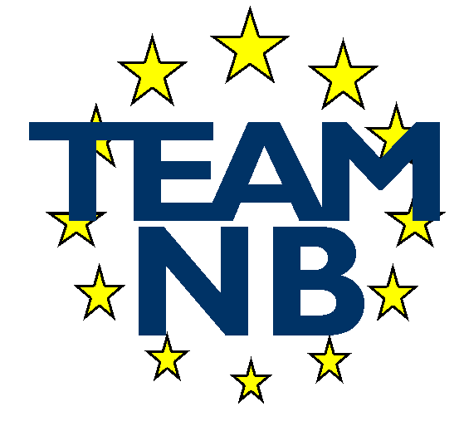  The European Association of Medical devices Notified Bodies | TEAM-NB A.I.S.B.L. Rue Bawepuce 20 B – 4140 Sprimont - BELGIUM Phone: +32 475 85 40 45 E-mail: assistant@team-nb.org Web: http://www.team-nb.org IBAN BE09 3401 5174 8757 VAT BE 0864 640 677

Editor : | Francoise SCHLEMMER |  | Date : | March 15th , 2023
PRESS RELEASE
Jump in the Team-NB’s Members

Team-NB membership increase of 26% since the last General Assembly Meeting of October 2022.
Code of Conduct mandatory
This has been made possible thanks to 2 measures adopted by the members.
The Team-NB members objectives are to allow the association to represent the vast majority of Medical Devices Notified Bodies in an aim to set up best practices guidances and harmonise interpretations to do the conformity assessments to allow the certificates delivery in ensuring safe and performing medical devices for the patients.
Candidate members
The Team-NB members decided to allow organisations who do not have yet the status of designated notified Bodies to join the association.
These organisations need to be in the designation process against at least one regulation.
This change in the Team-NB status with the creation of a new category of members called “Candidate Member” is a response to Authorities requirement to help capacity building (MDCG 2022-14 – point 6). Among others, the “Candidate Members” have access to the Team-NB trainings with the aim to harmonise notified bodies conformity assessments practices and help them to meet the regulations requirements. In addition, these members are allowed to participate to the Experts Harmonisation Sessions with the aim to allow senior experts of the subject matter to share their experience on « hot » topics to help answering challenges to conduct conformity assessment. The objective is that attendees cascade the info into their organisation to reach all reviewers.
Group members
During the General Assembly of October 5th, 2022, the members voted to set up an additional specific category, named "Group member". The aims are both to adapt the association to the coming merges among notified bodies and increase our association representativeness as wished by the Authorities.
To facilitate the agreement and the accessibility to the association, the organisation linked with a member of Team-NB will benefit from attractive Membership conditions.
All the organisations of a “Group” will benefit from the same privileges such as training at discounted prices, access to private part of the web site and to the Mirror-MDCG working groups and Team-NB task forces.
Team-NB is definitely the place for notified bodies to be informed of the latest trends and be authorised to participate in improving the legal framework.
Thanks to our political, the number of notified bodies members of Team-NB already designated against the regulations is peculiarly significant.

In case of any further clarification needed, please contact schlemmer@team-nb.org

