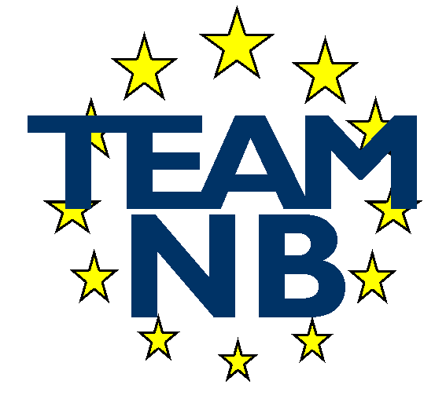  The European Association of Medical devices Notified Bodies | TEAM-NB A.I.S.B.L. Rue Bawepuce 20 B – 4140 Sprimont - BELGIUM Phone: +32 475 85 40 45 E-mail: assistant@team-nb.org Web: http://www.team-nb.org IBAN BE09 3401 5174 8757 VAT BE 0864 640 677

Editor : | Francoise SCHLEMMER |  | Date : | April 20th, 2023
22nd Anniversary Press Release

On April 18th, 2023, Team-NB, The European Association of Medical devices Notified Bodies had its 22nd anniversary.

The association formed in 2001 has today 40 members representing 20 countries.

At the end of 2001 we counted 23 members with a peak of 35 members in 2012. In 2013, some members made the choice not to implement the Code of Conduct that had become mandatory and
6 of them left the association. Our 40 members today is the result of the wish of the association to be representative, including 4 members which are still in the designation process. The aim is to allow all members to access information, allow practices to be compliant and to be as harmonised as possible.

Team-NB members represent more than 80% of the world-wide medical device Notified Body certification activities

On the occasion of our 22nd anniversary, a reception took place in Brussels at the NH Berlaymont Hotel with a panel of representatives of the Commission, CAMD, Industry, and of course of Notified Bodies represented respectively by Flora Giorgio, Thierry Sirdey, Petra Zoellner and Alexey Shiryaev.
The main theme of the panel presentation was to update on the state of the regulations with a specific attention to the new Regulation 2023/607.

Flora Giorgio thanked Team-NB for the goodwill and constructive approach always shown. She highlighted the efforts made to avoid shortage of devices on EU market thanks to the conditional extension of the transitional periods. She also underlined the need for Manufacturers to apply even for class D as there are tools to go ahead in the absence the designated EU reference laboratories.

Thierry Sirdey, as deputy chair of the CAMD promoted collaboration with all stakeholders and especially a new dynamic with NBs in building confidence.

Petra Zoellner foresees challenges for both MD and IVD and highlighted how the lack of EU Reference laboratories could be disruptive 2 years before the deadline.

Alexey Shiryaev emphasized the members’ efforts to increase capacities and the commitment to participate in implementation activities, enhance collaboration and develop best practices.

Gert Bos, former Team-NB president, today working for a consultancy firm, accepted the role of mediator to introduce the speakers, asking them questions on hot topics important for all stakeholders and ensuring a lively discussion.

Following Gert Bos’ question on important missing elements; it was answered EUDAMED, reinforced market surveillance, data to follow implementation progress, dialogue and predictability.

Concerning IVDR, it was clearly stated there will be no additional change in deadlines and some NBs indicated they received very few applications, so their staff were available to take them on immediately.

The participants represented all stakeholders and had the possibility to exchange views with the panelists and all present at a cocktail party that followed.

Team-NB, the European association of notified bodies in the medical devices sector is dedicated to ensuring a high level of patients’ safety and confidence.

This year Team-NB celebrates its 22nd Anniversary, and we are proud of the achievements we have driven in the global medical device regulatory world. Our three main areas of focus, have been and will remain:
- The promotion of innovation, backed by solid safety and effectiveness data.
- Our support to notified bodies, through our detailed and state of the art guidance documents.
- Continuous improvement of products, leading to increased patient access to safe innovative products.

Team-NB will stay at the disposal of all stakeholders, with the objective of ensuring a high level of patients’ safety and improving user’s welfare.

Contacts :
Director and Secretariat : | Francoise Schlemmer and Delphine Mestrez
Management : | Sabina Hoekstra-van den Bosch (TÜV SÜD)  Suzanne Halliday (BSI)  Gero Viola (TÜV Rheinland LGA)  Béatrice Lys (GMED)  Alexey Shiryaev (DNV)
Email | assistant@team-nb.org
Web site | www.team-nb.org

